f8-usva-tst Help-Live反馈 2026-6-12

general rule about how to deal with this feedback:

- The doc is provided by test team, some of the feedback actually in the snapshot, check the read text from the snapshot.
- The tester sometime is giving open questions, how to address it? Use the actual code to answer.
- If the tester feels that some part are not up to date with latest code, redo that session completely.
- If any line starts with Ryan - , our product manager, Use Ryan’s answer to make the change

https://crew-f8-usva-tst.roiscloud.com/fpqe/gantt/
Help菜单，Live部分，按顺序反馈

Live — Roster › Setting a date range
The date range selector right side missed a refresh button, the text has it but cannot see it from snapshot.
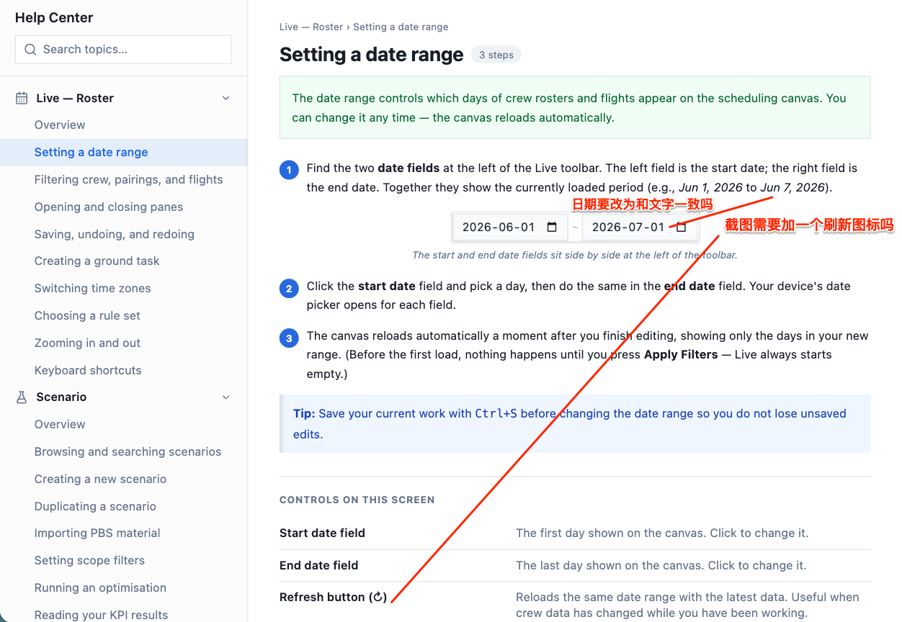

Live — Roster › Filtering crew, pairings, and flights
2.1 filter条件，手册示意图和文字，和目前UI不符合
（以下截图以crew的图片和pairing的文字为例，实际crew、pairing、flight的图片和文字都有差异，建议全部按照最新的UI更新）
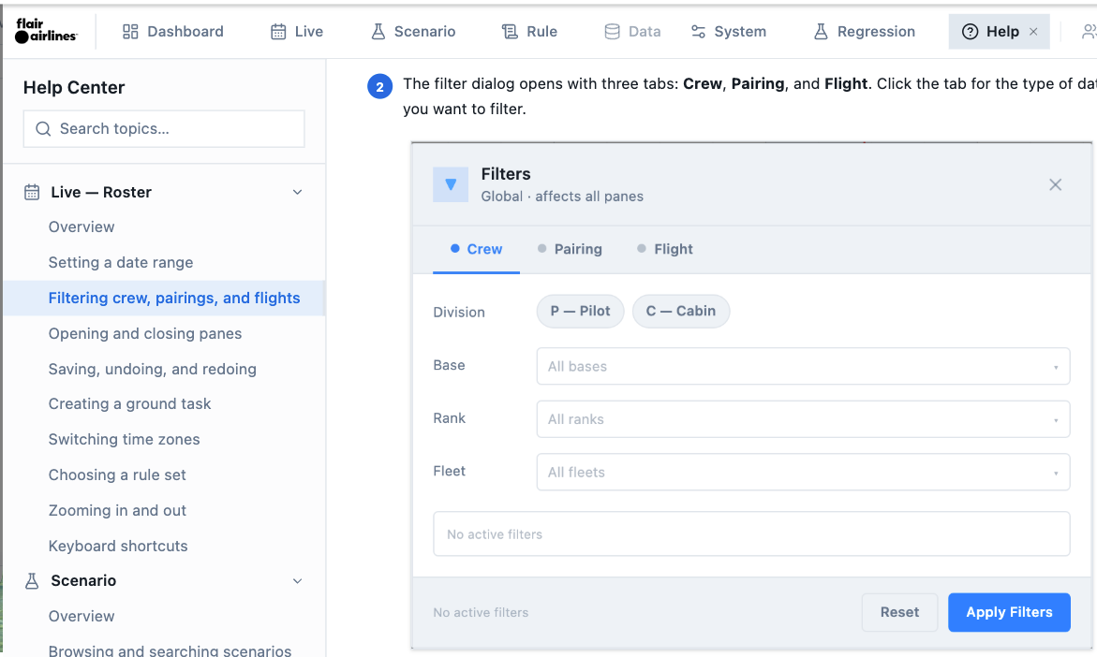
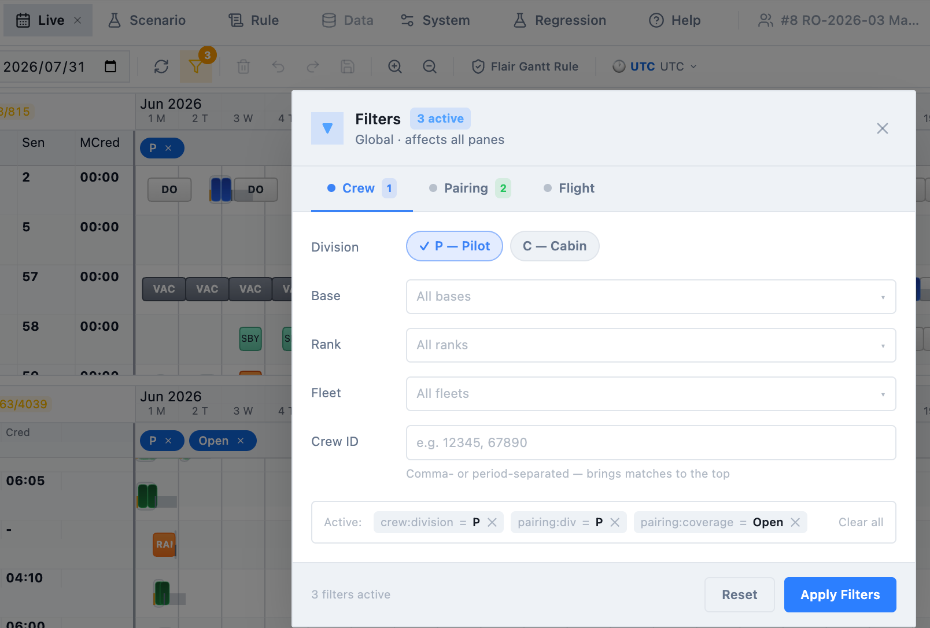

Sub-tab Pairing, missed some newly added filter criteria, such as coverage – Open and etc, need to add a snapshot here.
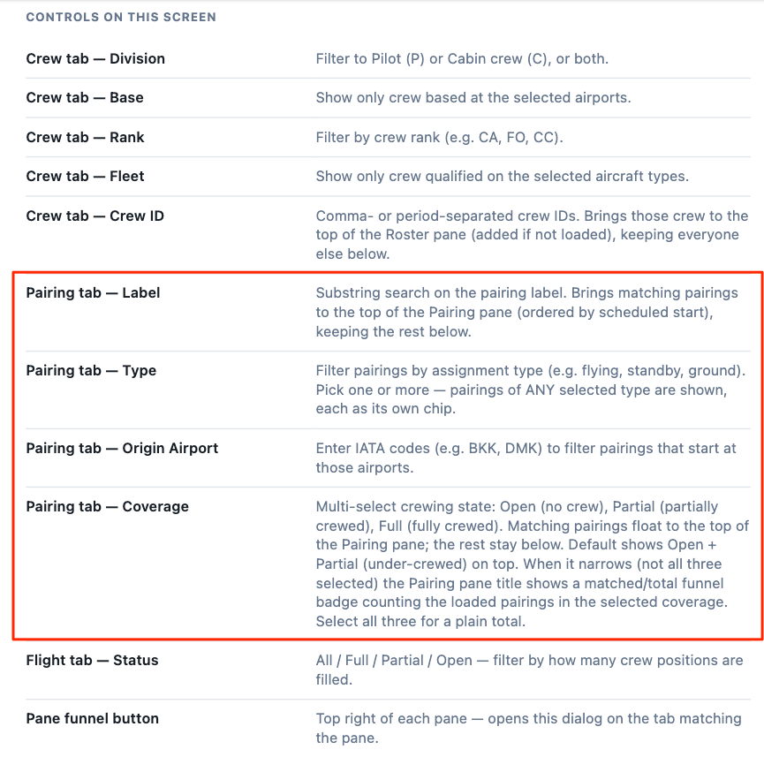
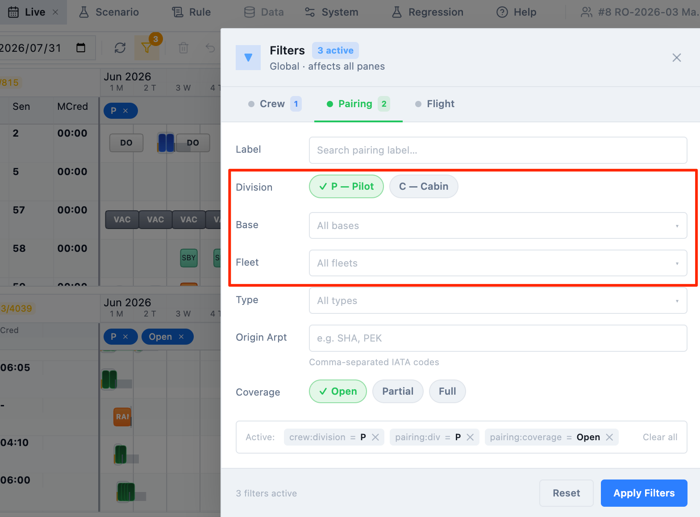

2.2 filter效果，手册示意图，和目前UI不符合

Ryan – the download icon and number was removed from code.
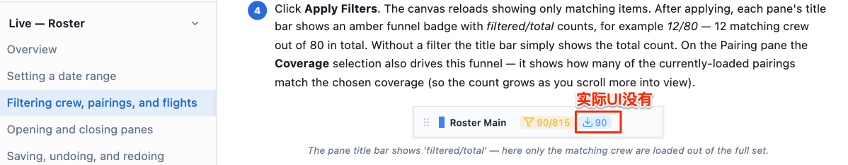

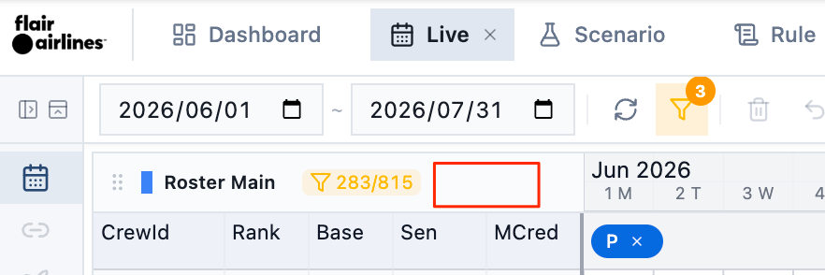

Live — Roster › Opening and closing panes
功能说明3～6已超出标题的Open/close范围，需要拆分出去，或者修改标题
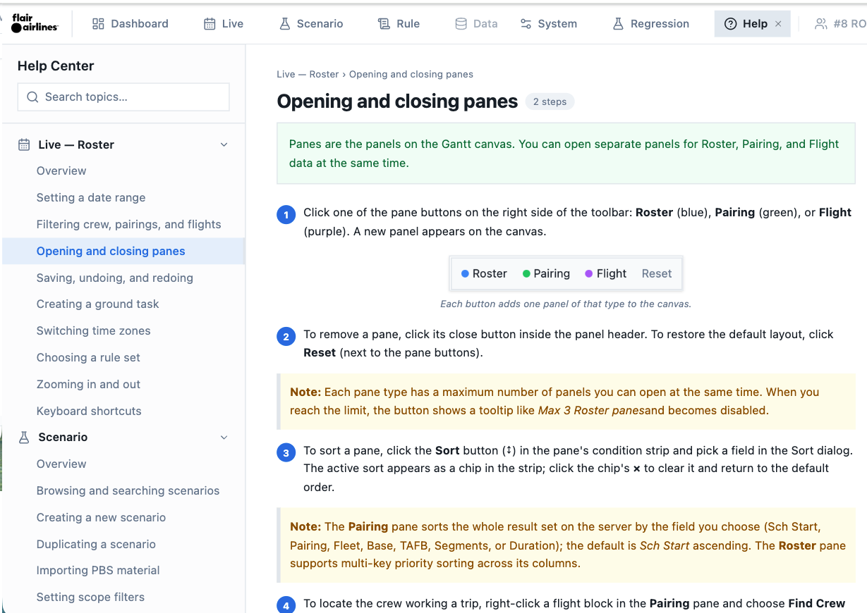

第2点说明，和UI不符，是UI有bug，还是说明文字需要修改？

Ryan – Max 2 roster pane, max 2 pairing pane, max 1 flight pane. Make changes to the help only
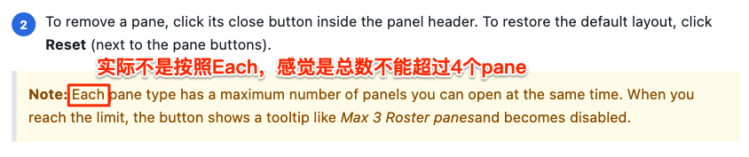
第4点说明，和UI不符，是UI有bug，还是说明文字需要修改？
Ryan – find crew flight is a newly added feature
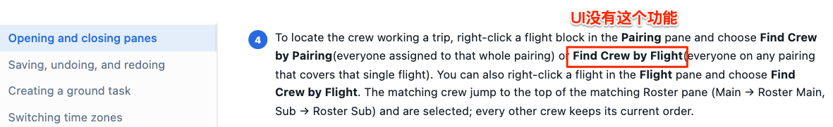
UI只提供根据pairing找
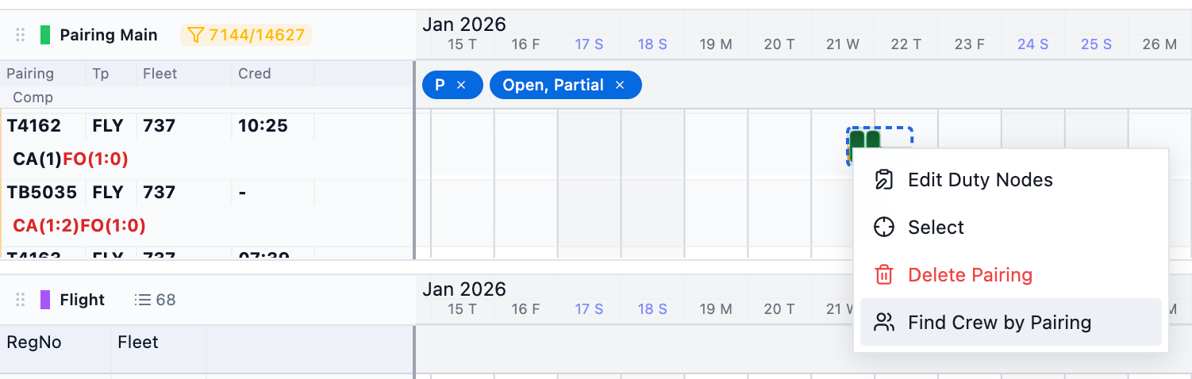

Live — Roster › Saving, undoing, and redoing
表达不统一
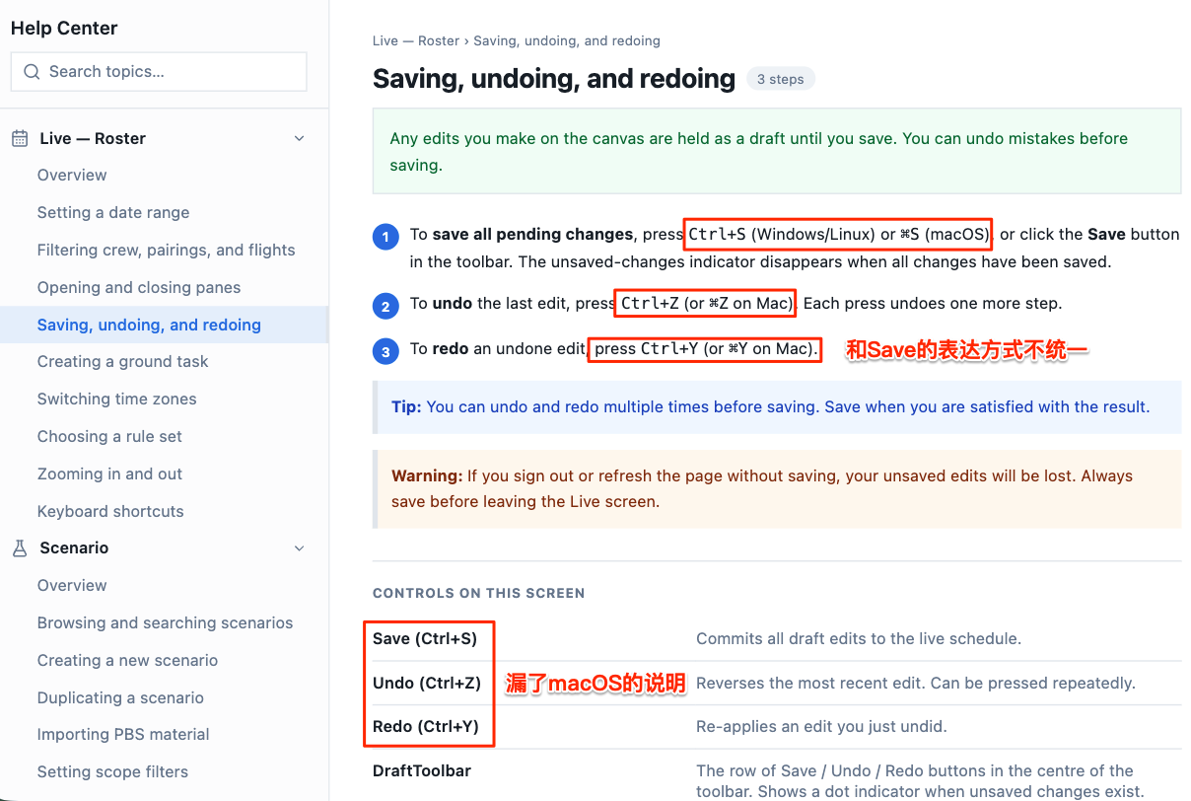

Live-缺少操作flight/pairing/roster的说明
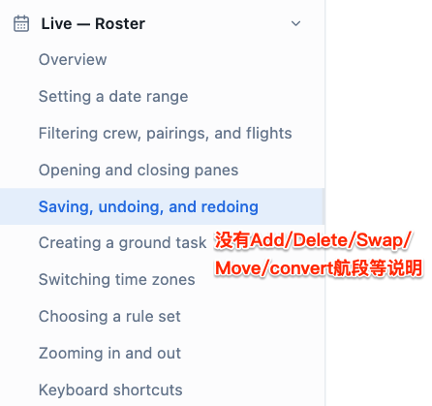

Live — Roster › Creating a ground task
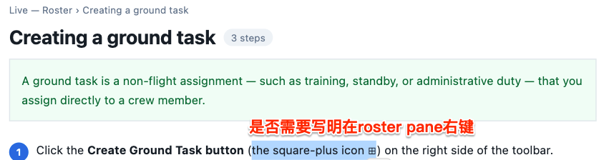
UI是Assignment和Group，是否要改手册文字？
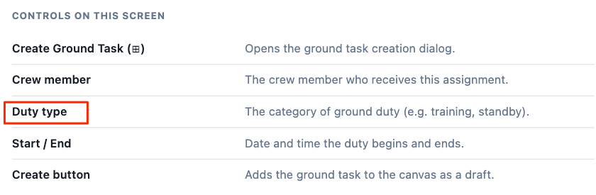

Live — Roster › Switching time zones
Ryan- has been enhanced
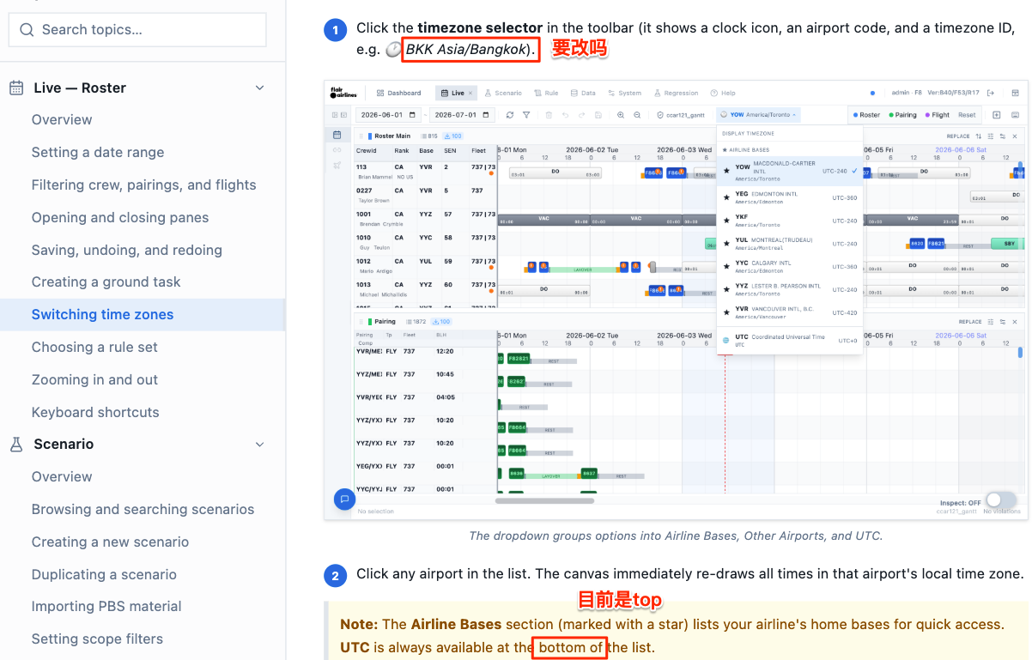

Live — Roster › Choosing a rule set
上面的示意图，和现在的UI不符合，未更新？
下面文字描述的Rule checking status功能，在UI上没看到

Ryan- the given snapshot was old,
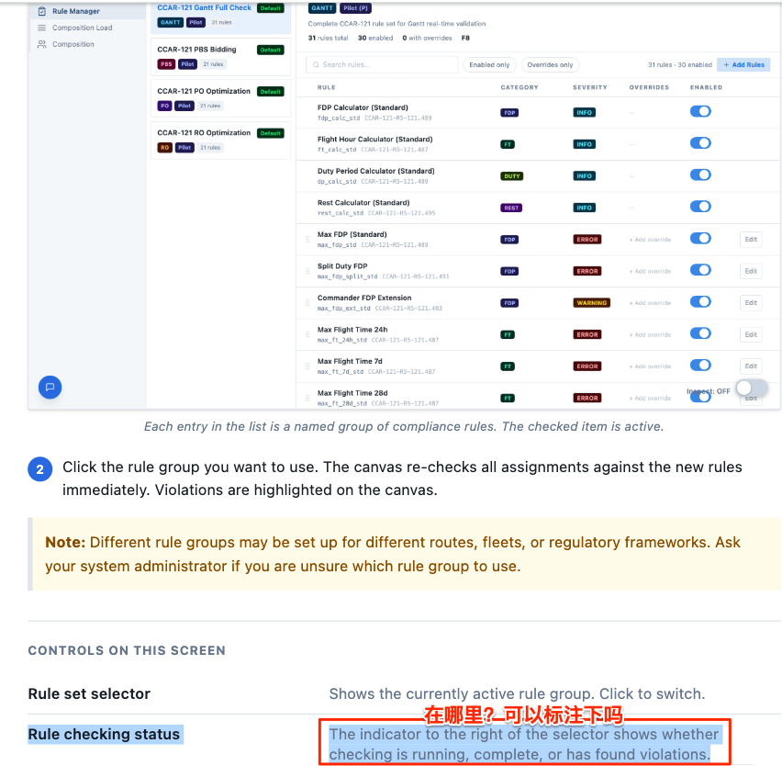

另外，Rule页面的操作，还没有Help，是否要等UI开发好了，统一加？

Ryan – update the part, which is ready

Live — Roster › Keyboard shortcuts
文字和UI有所不同

